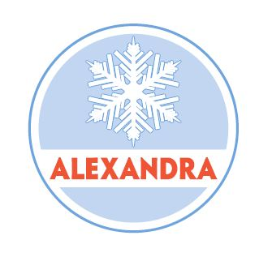

WAIVER OF LIABILITY

The Alexandra Ski Club has put in place a number of preventative measures to reduce the spread of COVID-19. However, the Club cannot guarantee that you, your guests or anyone else will not become infected with COVID-19. Further attending the Club could increase your risk of contracting COVID-19.

The Club has adopted the World Health Organisation Interim Guide and Operation Considerations for COVID-19 Management in the Accommodation Sector. You must familiarise and comply with those guidelines and ensure your guests do the same. You will find a copy at https://apps.who.int/iris/handle/10665/331638.

You must also comply with all Federal and State Government social distancing requirements and guidelines including the requirement to remain at a distance of 1.5 metres from any other individual.

You are also responsible for ensuring that all your guests comply with all COVID-19 requirements.

Any breach or non-compliance with any COVID-19 requirements may lead to a direction being issued to you and/or your guests to immediately leave the premises. If such a direction is issued you must comply with it.

By signing this form you agree to the above conditions and you also acknowledge the contagious nature of COVID-19 and voluntarily assume the risk that you or your guests may be exposed to or affected by COVID-19 by attending the Club and that such exposure or infection may result in personal injury, illness, permanent disability or death. You further understand that the risk of becoming exposed or infected by COVID-19 at the Club may result from the actions, omissions or negligence of yourself or others including but not limited to Club employees and volunteers.

You voluntarily agree to assume all of the foregoing risks and to accept the sole responsibility for any injury to you or any of your guests which may experience or incur in connection with attendance at the Club’s premises. You hereby release, discharge and hold harmless the Club, its employees, agents and representatives of and from any claims including all liabilities, claims, actions, damages, costs or expenses of any kind arising out of or relating thereto. You understand and agree that this release includes any claims based on acts, omissions or negligence of the Club, its employees, agents and representatives whether the COVID-19 infection occurs before, during or after your attendance at any Club premises.

You further agree that if you or any of your guests display any flu like symptom then you must immediately notify the Club.

………………………………………… …………………………………………

Signed Dated

…………………………………………

Print name

